login to LUMI through a personal device

*This guide is users who have registered a Lumi account with their agency or work email.*

You can login to Lumi from a stand-alone personal device – that is, a personal device such as a laptop or mobile phone with an Internet connection **without** access to your agency/work email, via remote access or any other means. To log in via a personal device, you will need to first ensure you have configured your access.

## Setting up access for personal devices

To login to Lumi from a stand-alone personal device*, you need to have **first registered a Lumi account and have accessed the account.** Once set upyou will be able to assign a **secondary email** (so you can receive Two-Factor Authentication emails when logging on via your personal device).

**\*** Being *‘logged in from a stand-alone personal device’* means that you have a personal device with an Internet connection and DO NOT have access to your agency/work email.

## Screenshot of the Lumi Login Screen. The Username and Password section is highlighted.STEP 1: Login to Lumi using your agency/work email

*Ensure you have access to your Agency/Work email as you need to access the Two Factor Authentication email.*

1. Login to *Lumi* via the website address: <https://lumi.dfat.gov.au>.
2. Enter your **agency/work email address** (the email address you used to create your account) and your **Lumi password** under ‘For DFAT Employees not logged into the DFAT ICN Network And for Non-DFAT Employees already registered’.

***NOTE:*** *Do* ***NOT*** *enter your secondary email address to login as this is only being used to receive Two-Factor Authentication emails (and other notifications) to enable you to login while you are unable to access your   
agency emails.*

## STEP 2: Setting up a Secondary Email

1. While logged into Lumi, select the **My Learning** button at the top of the Home page.

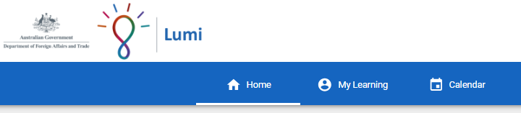

1. Select the **VIEW MORE** button in your personal details section.

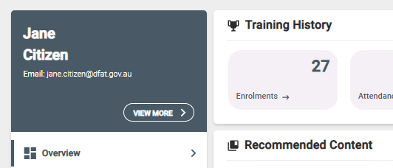

1. Navigate to the **Secondary Email field** and enter in an alternate email address you will have access to on a personal device (such as personal email).

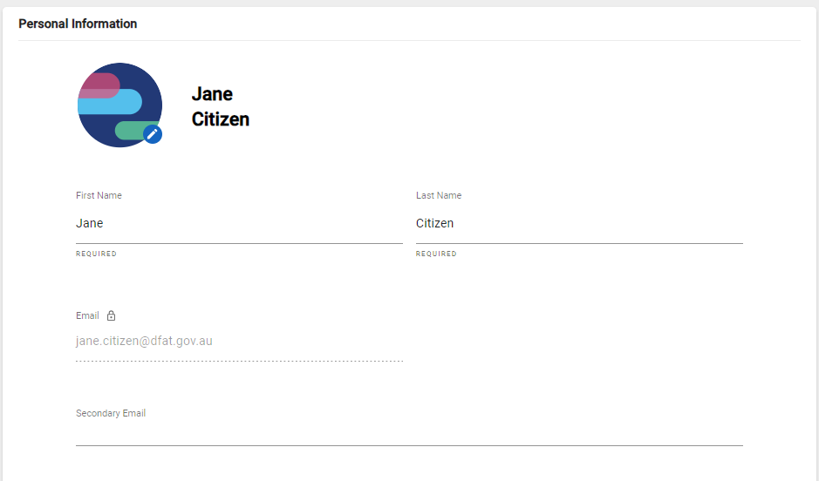

1. Select **SAVE CHANGES** at the bottom of the Personal Information form to save your email.

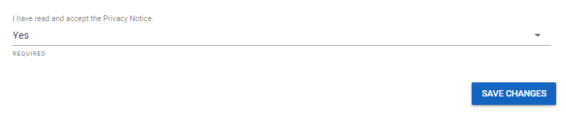

1. You will now be able to receive emails to both your agency/work and secondary email account.

***NOTE:*** *While you have access to your Agency/Work email, please log out and log back in to ensure the Two Factor emails are now being sent to your personal device.*

*You only have to set this up once. You can change or remove your secondary email at any time through the Personal Information menu.*

## STEP 3: Login to Lumi from a Stand-Alone Personal Device

1. Login to Lumi via the website address, <https://lumi.dfat.gov.au>.
2. Enter your **agency/work** **email address** and your **Lumi password** under ‘For DFAT Employees not logged into the DFAT ICN Network And for Non-DFAT Employees already registered’.

***NOTE:*** *Do* ***NOT*** *enter your secondary email address to login as this is only being used to receive Two-Factor Authentication emails (and other notifications) to enable you to login while you are unable to access your ‘.gov.au’ emails.*

1. Select **‘LOGIN’**. A code will be sent to your personal device/secondary email.
2. You can also refer to your secondary email account to access any system-based notifications.

## Logging Out

To logout, select the **‘Profile’** icon in the top right-hand corner of Lumi and select **Logout**.

