Register Account and login to LUMI

*This guide is for external users who would like to register and log into Lumi.*

The Department of Foreign Affairs & Trade (DFAT) trains Australian officials in international engagement tradecraft, including in areas such as advocacy, negotiation and forecasting strategic planning. Approved externals can **enrol** and **pay online** (where applicable) for DFAT’s learning programs via our Learning Management System, *Lumi*.

If you are currently an APS employee, it is strongly recommended that you **register using your ‘.gov.au’ email address** as they are automatically authenticated by Lumi.

If you need to register using a *non-.gov.au* email address, please provide detailed information for your reason for registering and a DFAT contact who can verify your need for a Lumi account.

## Register for a Lumi Account

*Before you begin, please ensure you have access to the email you will use as your registration email.*

1. Through the browser, navigate to <https://lumi.dfat.gov.au>.
2. Select ‘**REGISTER (NON-DFAT EMPLOYEES)**’.

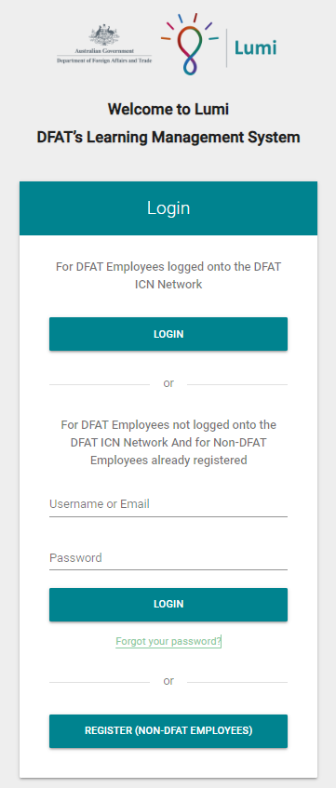

1. Screenshot of the Lumi registration form. The fields that are referenced in the instructions (Register for an account section,  number point 3 fill in the required details) are marked with a matching letter.
   These are: 
   a, Email, 
   b, Mobile Phone, 
   c, Affiliation, 
   d, Do you have a DFAT contact who can verify your need for this account?,
   e, Are you a Dependant or Spouse of a Pre-Postee, 
   f, I have read and accept the Privacy notice.

   The Please read the Privacy Notice (link) before registering an account is highlighted.Fill in the required details. Additional support is as below:
   1. **Email Address**: this will become your username and will receive all communication from Lumi. *Please enter a ‘.gov.au’ email if you are an APS employee*.
   2. **Mobile number**: Please provide a contact number, this can be landline as long as you provide area code.
   3. **Affiliation**: Please provide your affiliation. Depending on your response, you will need to provide details about your affiliation.

**(a)**

* 1. **DFAT Contact**: Please provide the name of a DFAT contact who can endorse your account. *Contact can be the name of a team that invited you to Lumi or is advertising the course.*

**(b)**

* 1. **Dependant:** For Dependants of Pre-Postees, please specify if you are a Dependant.
  2. **Privacy Notice:** Please review and accept the Privacy Notice. A copy is available via the Privacy Notice link above the form.

1. Select **‘REGISTER’** to create your account.

**(c)**

1. Once you have registered, a verification email will be sent to your email account. **Please select the verification link** in that email.

Once you have verified:

* 1. ‘*.gov.au*’ email users will be granted automatic access to Lumi.

**(d)**

* 1. All other users will undergo additional security checks. If approved, you will receive notification that your account is active. This can take up to 2 business days (Mon-Fri).

**(e)**

1. Once access is granted, you can return to the Lumi login screen ([lumi.dfat.gov.au](https://icnprod01.sharepoint.com/sites/CHCH-PPD-DiplomaticAcademy/Shared%20Documents/Lumi/QRGs/Externals/lumi.dfat.gov.au)) and log in with your username (email) and password.

**(f)**

**Note:** If you do not receive a verification email/approval, or require approval within 2 business days (for users without a .gov.au email), please contact [diplomaticacademy@dfat.gov.au](mailto:diplomaticacademy@dfat.gov.au).

## Navigating Lumi

You are now ready to use Lumi to browse, register, enrol and track your learning. From the home screen you can:

1. Use *Search* feature to search for a specific course
2. Access DFAT’s external *Catalogue* of learning courses, videos and resources
3. View the *Calendar* for live learning sessions (Face-to-Face & Face-to-Screen (E.g. Teams)

**(2)**

1. Access your Training (My Learning) History

Screenshot of the header bar of the Lumi homepage.

The image is highlighted with 4 numbers matching that of the number points of the Navigating Lumi section.

These are:
1, the search bar
2, the Catalogue button
3, the My Learning button
4, the Calendar.

**(4)**

**(3)**

**(1)**

## Logging Out

To logout, select the **‘Profile’** icon in the top right-hand corner of the Home page and select **‘Logout’**.

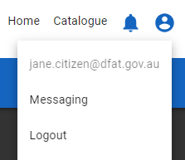

## Login to Lumi Once Registered

1. Login to Lumi via the website address, <https://lumi.dfat.gov.au>.
2. Enter your **registered** **email address** and your **Lumi password** under ‘For DFAT Employees not logged into the DFAT ICN Network And for Non-DFAT Employees already registered’.
3. Enter in the **Multi-Factor security code** that will be sent to your registered email.
4. Select ‘**LOGIN**’.